Ziegler elementary

the soaring eagle FAMILY NEWSLETTER

February | 2021
NEWS & NOTES
School Reopening Details
- February 22nd: K-2 students who opted for hybrid learning in the fall will return to class on selected days (Monday/Tuesday or Thursday/Friday)
- Wednesday’s will be an all virtual day for all students, even K-2
- There is no timeline for other students to “opt-in” to hybrid learning
- There is no timeline to return for students in grades 3-8
- We will communicate new information as soon as we know!
- K-2 staff will return to Ziegler on February 8th to plan and prepare for hybrid learning

PRINCIPAL’S NOTE
A safe reopening

As of today, we’re scheduled to start bringing students back to school on Monday, February 22nd.

We believe we can follow all guidelines and do our best to ensure the safety of students and staff.

How? Masks, distancing, and sanitizing. We will mask up, maintain proper distance, and sanitize our hands and the building frequently.

We will start with just 41 students – that’s the number of Ziegler families who opted for in-person learning.

That means, on any given day, just 20 students will be spread across 7 classrooms. That will allow us to refine our systems and procedures as we prepare to hopefully bring more students back.

We have spent a long time away from school. I am excited to see everyone, and I am also aware this can be scary. I and the entire Ziegler team are here to support you.

I hope to see you soon. Safely.

-Mr. B
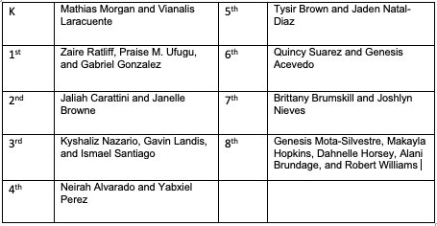
Students of the Month!
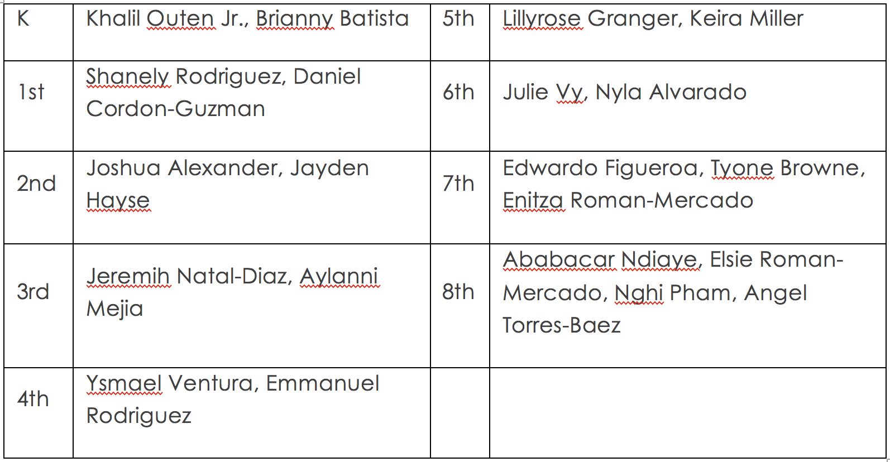
- Black History Month
As you all may or may not know but February is Black History Month, so we at Ziegler are making sure to incorporate this important history into our curriculum this month. The teachers have prepared slides for each day of the month that is to teach students about civil rights and African Americans who have made a grand impact of change in the United States.
- Virtual Tutoring
If you feel that your student is falling behind or has been behind this school year academically, sign them up for free virtual tutoring! This program involves honor students at North East High School who are available and willing to aid your students re- learn what they might have misunderstood and boost their academic confidence. Sign up via this link or email mschlosser-ext@philasd.org today!

Upcoming Events!
February 3-5: 12PM Dismissal + REPORT CARD CONFERENCES
February 4th: PBIS day
February 8^{th:}: K-2 and related staff return to building
February 15: NO SCHOOL (President's Day)
February 22: Some K-2 students return for hybrid

